**Ex22andEx35Chp4**

**Exercise-22-Chapter 4**

In Fig. 4-27, four stations, A, B, C, and D, are shown. Which of the last two stations do you think is closest to A and why?

Station C is the closest to A because it is able to hear the RTS and respond with a NAV signal whereas D was out of the range to hear the RTS.

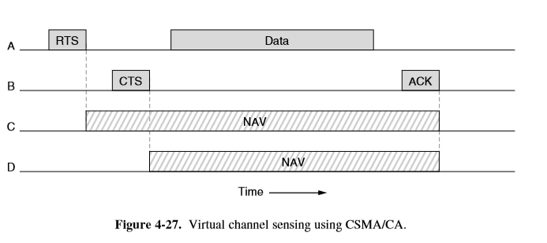

**Exercise-35-Chapter 4**

List some of the security concerns of an RFID system.

Some of the security concerns of an RFID system include that an RFID tag can be easily tracked and the ability of the reader to change toe information that is in the RFID tag,